

Basic Features and Operation

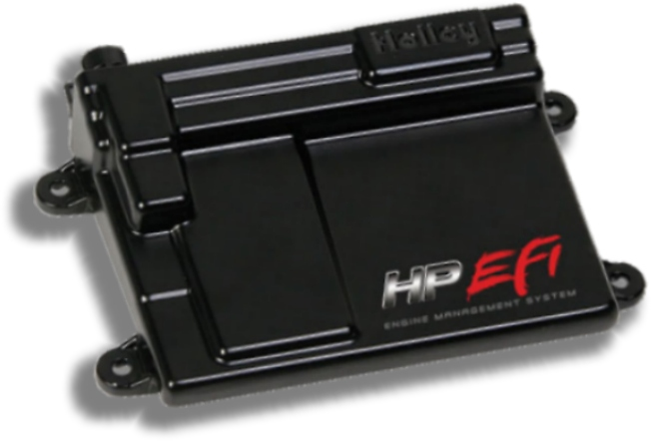
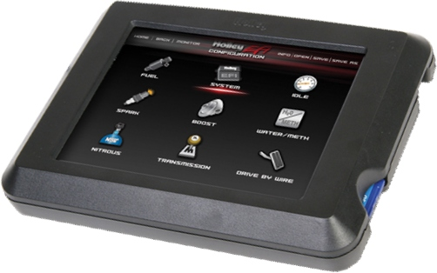
The Holley HP and Dominator EFI offer state of the art computer controlled vehicle management for your drag race motorcycle. The Holley EFI was designed as a total solution and is not a plug and play system. If programming without a laptop, or if gauges are desired, the LCD Touch Screen (P/N 44-553-103) can be configured with several different dash arrangements to display any data that the ECU is seeing. For example, it can display a standard tachometer or a bar type, A/F (air fuel ratio), fuel pressure, nitrous pressure, boost, oil pressure, etc. You can program all tuning screens (Fuel, Spark, Nitrous, Boost, etc) from the LCD Touch Screen with the exception of system parameters. Holley EFI controls all systems, including Fuel, Ignition, Accessories, Nitrous Control, Boost Control, and Data Acquisition. The HP and Dominator both have 2 dedicated inputs, one for fuel pressure and the other for oil pressure. The HP is a smaller unit and works great on a motorcycle. It has 4 user configurable inputs and outputs while the Dominator has a massive 30+. The user configured inputs are used for things like Launch Limiter Activation, Data Log Activation, Nitrous Activation, Rear Wheel Speed, Dome Pressure, Nitrous Pressure, Track Temperatures, Individual Cylinder A/F, Cylinder Exhaust Gas Temperature, Tire Temperature, and any other 0-5vdc sensor you can imagine to use. As you can see there are many more than 4 possible inputs so when choosing your ECU the number of inputs you need will determine the correct choice of ECU. You will typically use fewer outputs than inputs. The typical Outputs are: Shift Light, Auto Shift, Nitrous, Boost Control + Solenoid, and Boost Control - Solenoid.

There are two options for ignition coils. The first is using the factory stick type coils and an igniter (P/N 1-0631). The igniter uses the 5v signal from the ECU to in turn control standard 2 wire coils. The second is four smart coils (4 wires) like GM LS2 (P/N 1-12573190) and 8.5mm MSD wire set (P/N 1-0570). The smart coils are triggered directly by a 5v signal sent from the ECU. For motorcycles we use a custom ignition strategy. This involves removing teeth from your original ignition rotor. You will need to remove all but 2 teeth. The 2 remaining teeth need to be located anywhere from 50 degrees BTDC to 80 degrees BTDC on #1 cylinder and 50 degrees BTDC to 80 degrees BTDC on #2 cylinder 180 degrees from each other. The tooth position at the pick up expressed in degrees BTDC should be entered in the Ignition Reference Angle in the ignition set up screen. You will need to verify correct timing and adjust the Ignition Reference Angle accordingly on initial start up. The HP or Dominator can be configured to use either a Bosch (P/N 44-554-101) or NTK (P/N 44-554-100) O2 sensor. The NTK is the fastest and most accurate of the two. The Dominator has a built in provision to use two O2 sensors. They both will run up to 3 sets of high or low impedance injectors, at fuel pressures up to 75 psi. All basic sensors are configurable for Holley sensors or any custom configurations. Turbocharged applications normally use either a 3, or 5 bar MAP (manifold air pressure) sensor.

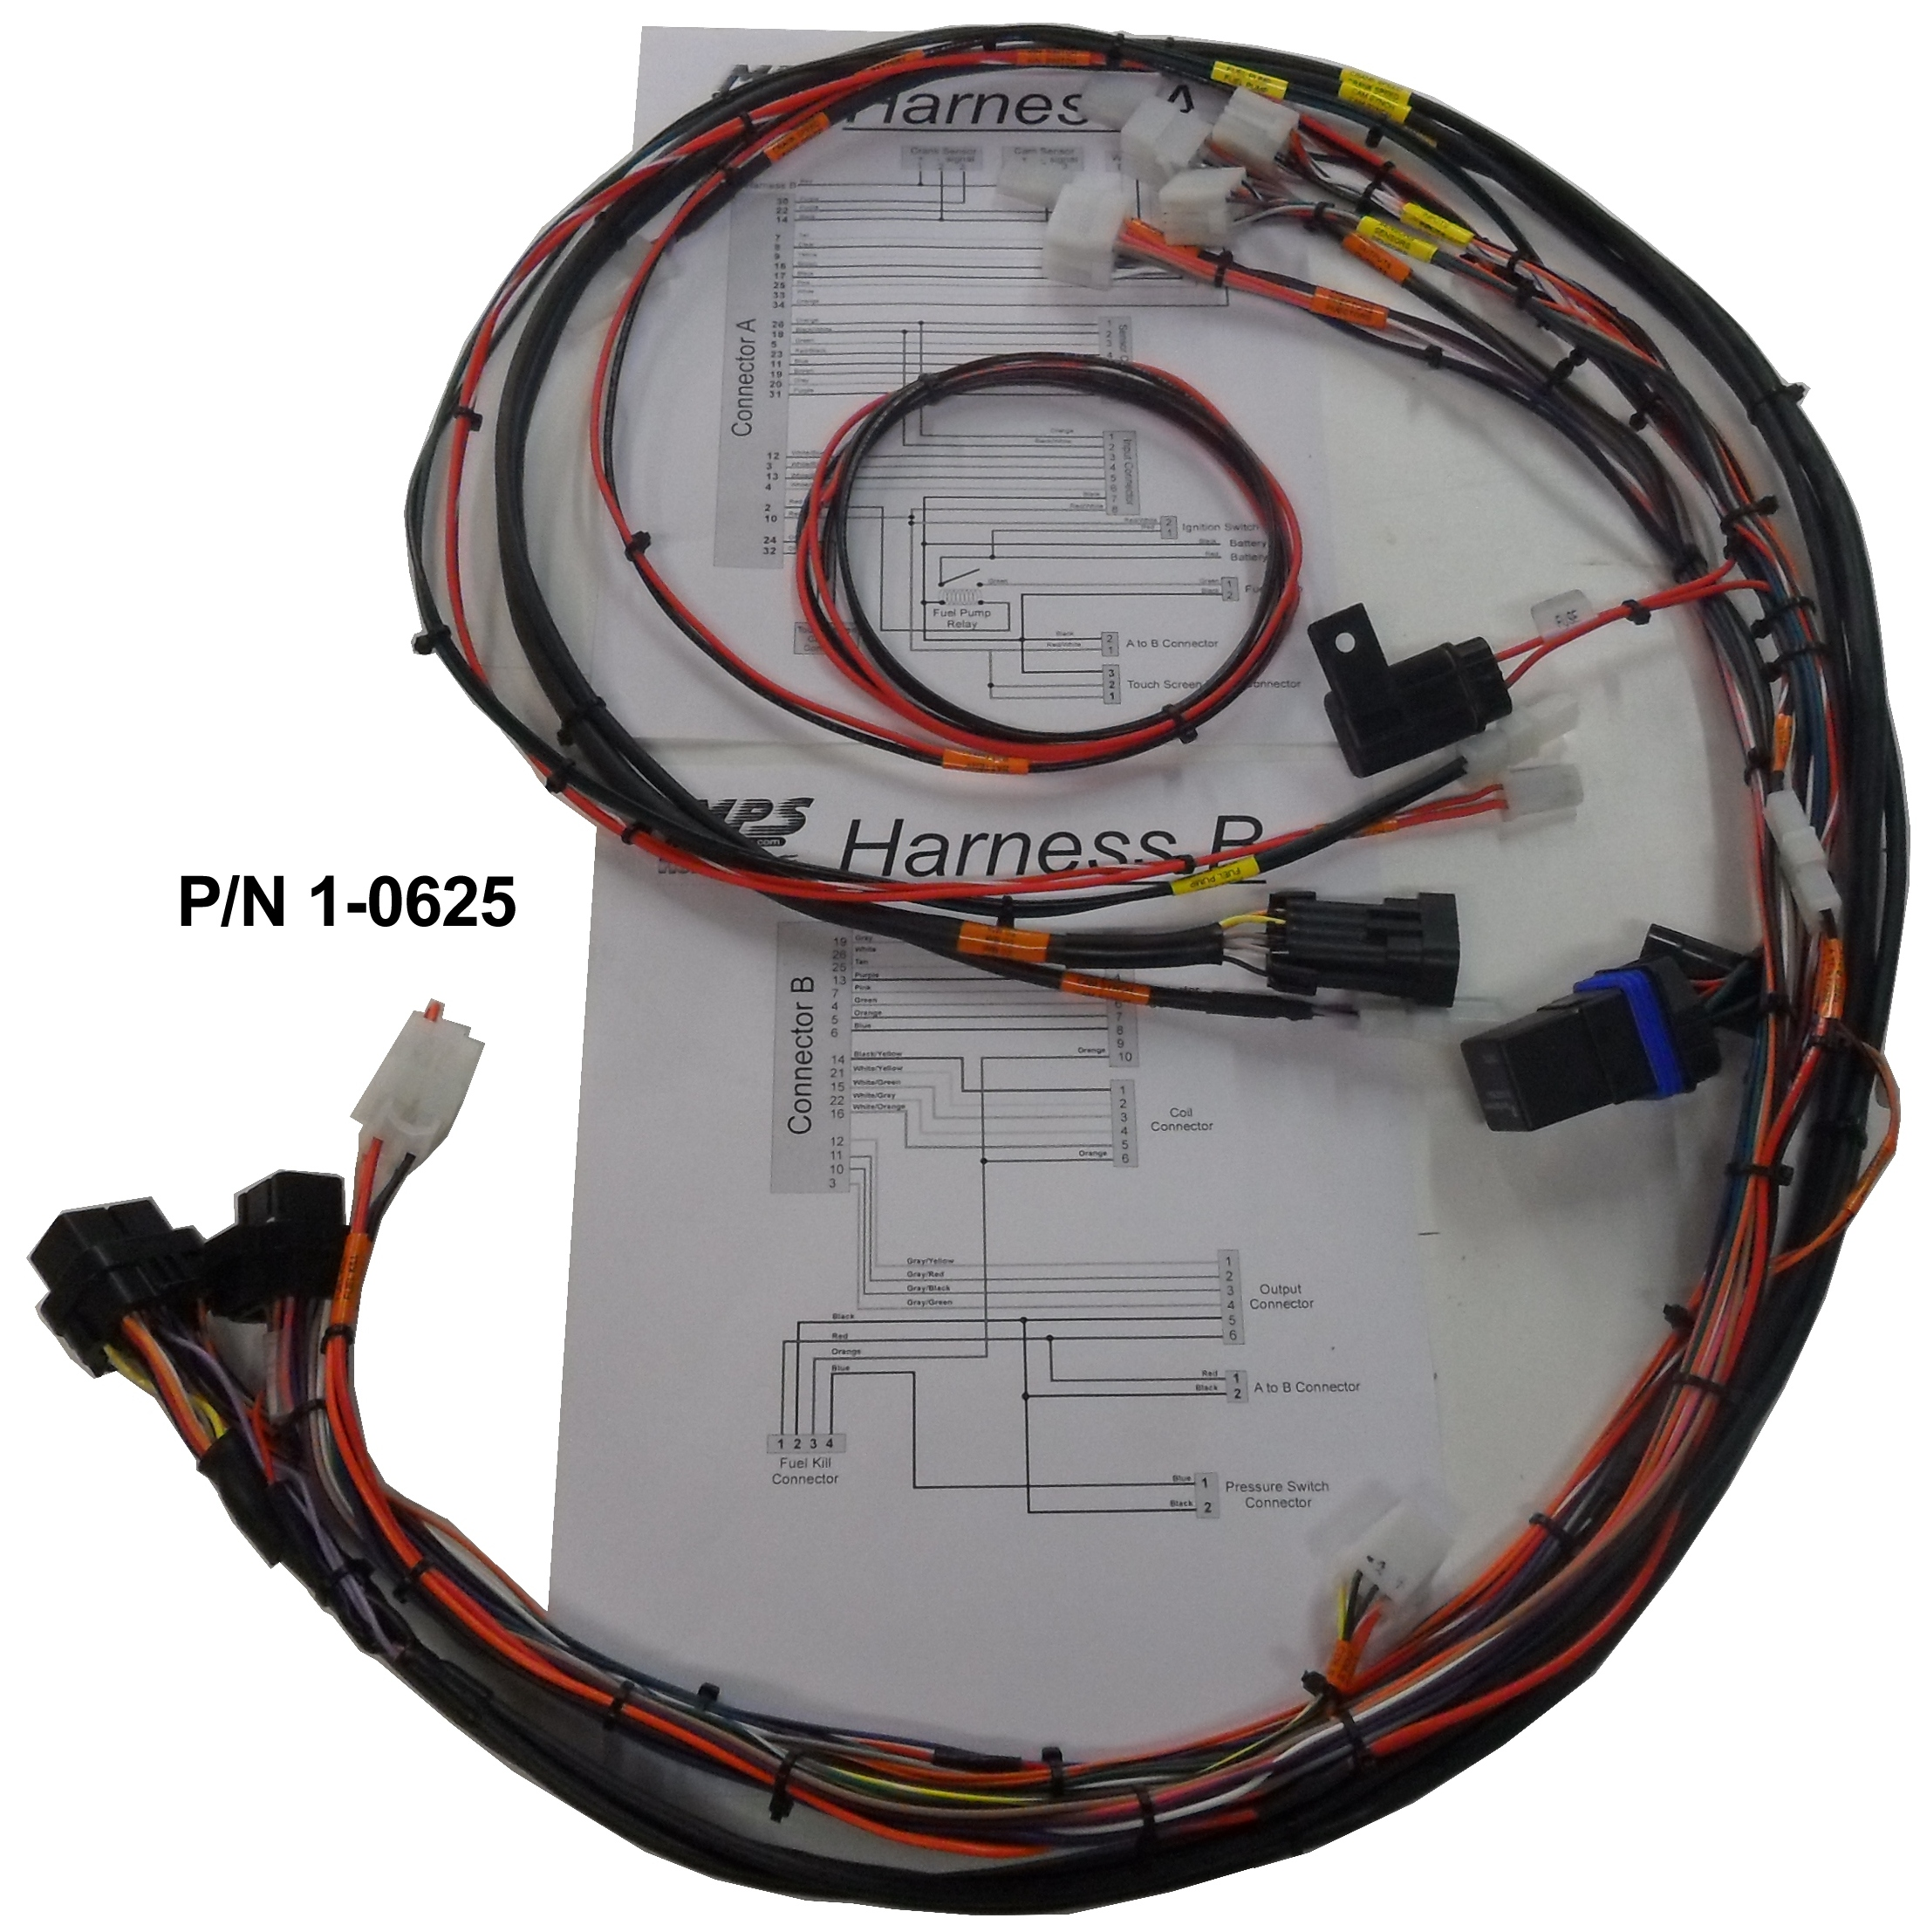
A good thing about the harnesses is that if you buy an HP, and later decide you need more inputs you can plug your existing HP wiring directly into the Dominator ECU. Wire harnesses for either ECU come in three different configurations. First, the Holley Unterminated Harnesses (P/N 44-558-105) and the Holley Power Harness (P/N 44-558-308) are the base harnesses and come with 25 feet of wire on each pin with a multiple conductor cords for the 02 sensor, crank, and cam sensor. The second type of harness (P/N 44-558-105 + P/N 44-558-308 + P/N 1-0564), we modify by taking out all unnecessary wires and adding all needed 5vdc and ground sensor leads. We then bundle and label all wires. This makes a great custom installation without the custom price. You will need to terminate all the wires on these harnesses. The third type is our EZ Harness (P/N 1-0627) and is mostly plug in. This harness has most of the wires terminated with the proper connections for the ignition coils (you must specify coil type being used), injectors, sensors, etc. It has terminated ends for your ignition switch, shift light, auto shift arm switch, air shifter air valve, launch limiter, data log switch, nitrous solenoids, nitrous relay, boost control solenoids, etc. Or you can have your Holley EFI professionally installed at MPS.

The Holley HP & Dominator EFI both feature self-tuning and closed loop operation. We will go over the closed loop function first. Closed loop means the ECU will make adjustments to the fuel delivery on the fly based on A/F read from the O2 (oxygen) sensor in the exhaust. If your bike doesn’t have an 18mm bung in the exhaust you will need to install one.

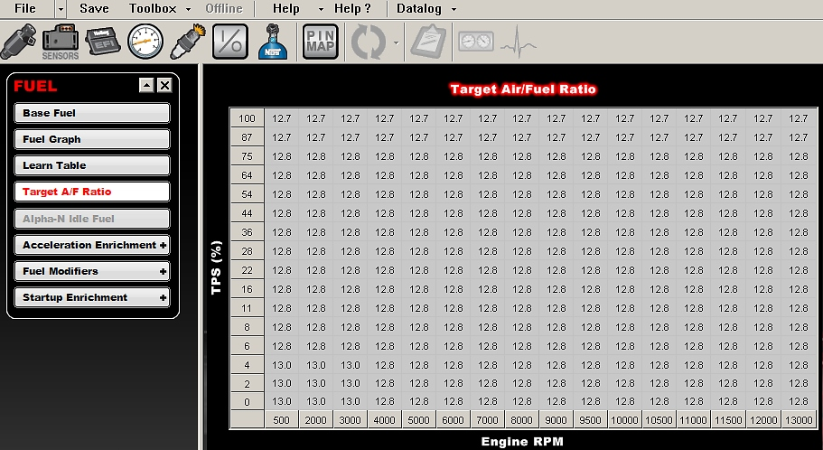
The target A/F table has an RPM axis and either a TPS (throttle position sensor) or MAP axis. You input the A/F you want to target at any given RPM and TPS/MAP. For example: If you put 12.8:1 A/F in every square of this table the ECU will add or subtract fuel until the 12.8:1 A/F is reached. If you have a turbo bike, you may want to target 12.8:1 at 0 psi and 12.0:1 at 10 psi. The ECU is incredibly fast and makes these changes almost instantaneously.

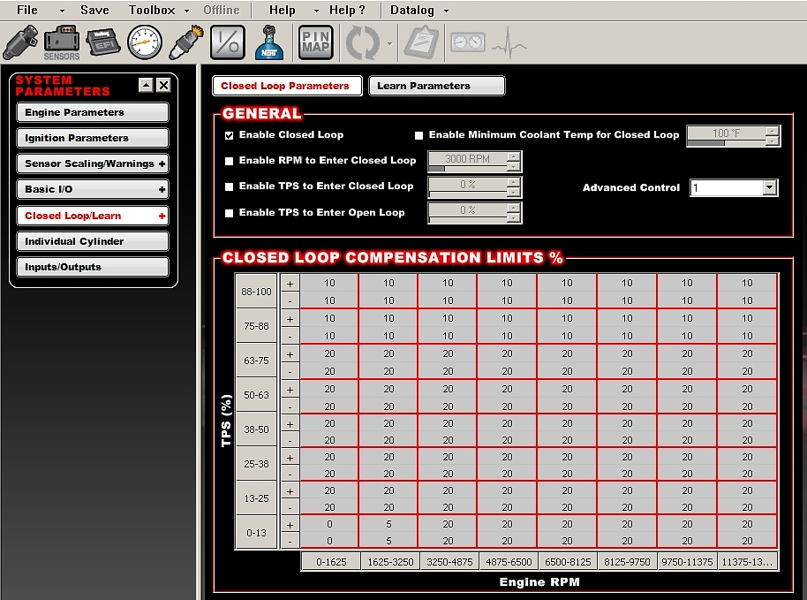
The ECU has closed loop compensation limits that are set in the closed loop compensation table. This is where you tell the ECU how much fuel as a percentage it can either add or remove from the base fuel table at a given throttle position or MAP sensor pressure. For example: at idle, you could only allow the closed loop compensation to remove 5% and add 0%, but at 100% throttle position at 10,000 rpm you may have +40% and –20%. Generally you will allow the ECU to compensate less and less as you fine tune your fuel tables. Initially you will start with high percentages in the closed loop compensation tables to allow the ECU to add or subtract enough fuel to hit the target A/F. Closed loop is a tuning tool and is not a substitute for the proper fuel map. Your data logs shouldn’t have more than 5% closed loop compensation when your bike is tuned correctly.

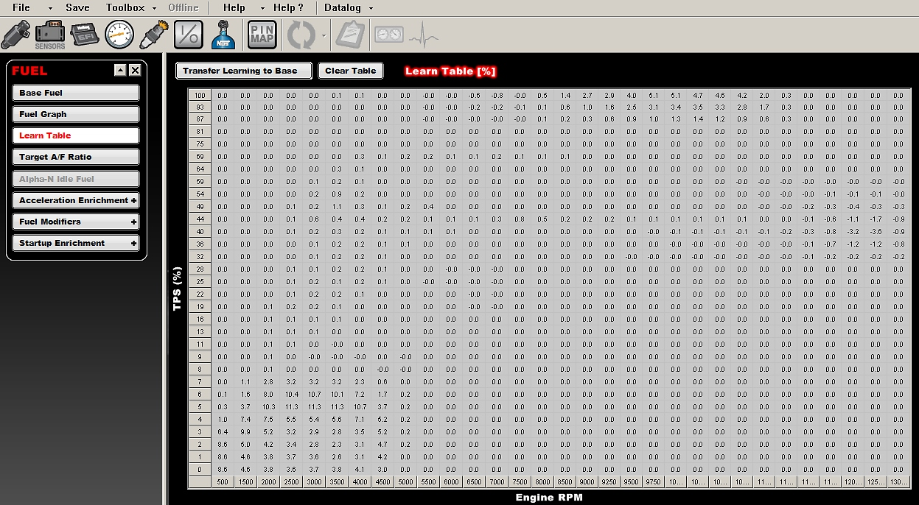
The self-learning looks at what the ECU had to do to arrive at the target A/F then populates the learn table with the percentage of fuel it had to add or subtract. The learn table can then be transferred to the base fuel map. This changes the base fuel map by the percentages in the learn table permanently. When first tuning you want to run the bike at lots of varying loads and engine speeds to populate the learn table. You can adjust how much and how fast the learn table can populate as well. The self-learn feature is a big help to get to a rough tune good enough to run the bike.

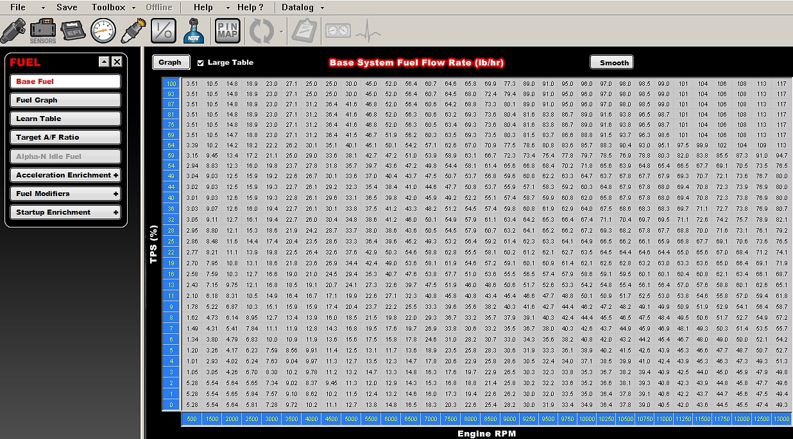
The base fuel table has an RPM axis and either a TPS (throttle position sensor) or MAP (manifold air pressure) axis depending on whether you have chosen speed density or alpha N fueling strategy. The alpha N is TPS based and the speed density is based on manifold vacuum/pressure. For drag racing we use alpha N for everything except turbocharged applications. The numbers in this table are expressed in pounds of fuel per hour. By using the Brake Specific Fuel Consumption (BSFC) for your type of engine (Normally Aspirated .450 -.550 and Nitrous & Turbo .550 - .700) you can get pretty close to the correct wide open throttle fuel numbers. For example: if you expect to have 200 normally aspirated horsepower you would multiply 200 HP x .5 (BSFC) = 100 lbs/hr. Fine tuning your fuel table is usually done by using a datalog of the bike running in the area you want to tune. You open your fuel table, then your data log, by using the arrow key and moving along your data log you will see an orange ball on your fuel table where the bike was running at that moment in the data log. By looking at the closed loop compensation you can tell whether it was rich or lean and how much. If closed loop compensation says 1.25 that means it had to add 25% more fuel to get to the target A/F. You would multiply the value in the fuel table by 1.25. This will be very close to the correct fuel for that RPM at this throttle position or manifold vacuum/pressure.

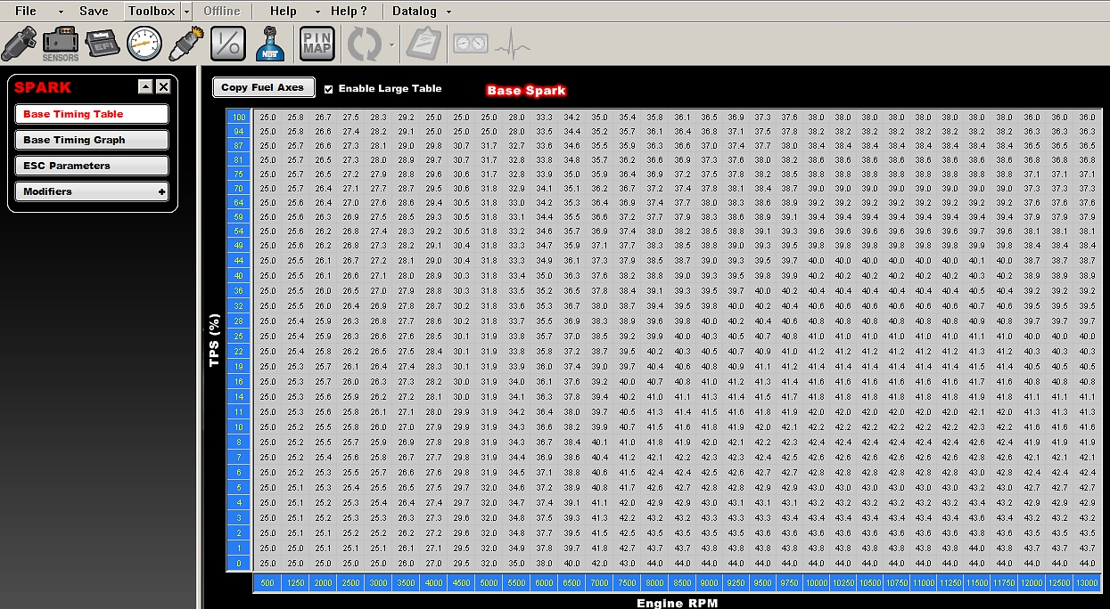
The base ignition table has an RPM axis and either a TPS (throttle position sensor) or MAP (manifold air pressure) axis just like the fuel table. The values in this table are the number of degrees before TDC to fire the spark plugs.

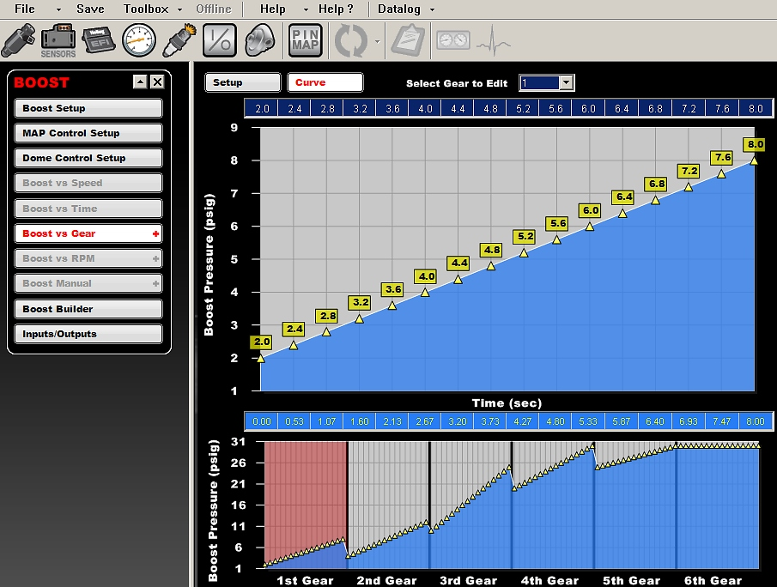
The Boost Controller compares with stand alone controllers costing as much as the HP ECU. The first thing you will need to determine what type of wastegate you are using. This will either be a single port or the preferred dual port type wastegate. You will need one 3 way boost control solenoid (P/N 1-0037) with a single port waste gate or two 3 way boost control solenoids and a dome pressure sensor (P/N 1-0601) for the dual port wastegate. The boost controller features a launch boost target, boost scramble, and an extensive boost safety system to protect your engine from any malfunctions. The controller can be programmed for boost vs. speed, boost vs. time, boost vs. rpm, or boost vs. gear.

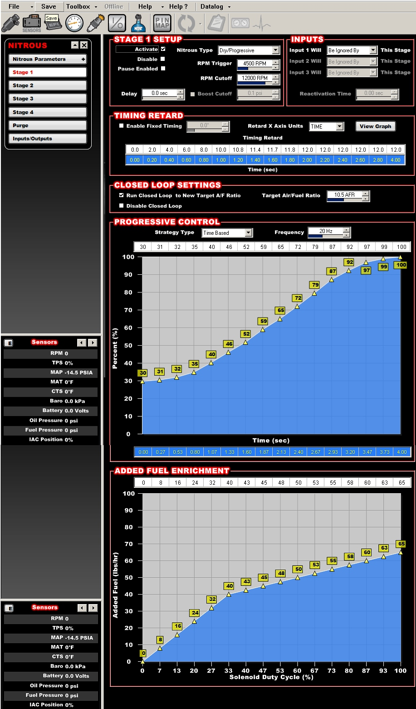
The Holley ECUs feature a state of the art nitrous controller built in. The nitrous controller can be set up to control a progressive or non-progressive, wet or dry, nitrous systems with up to 4 stages. We prefer a dry system because of the ability to control fuel more precisely. Basic parameters such as: TPS percentage to activate, RPM to activate, RPM to de-activate, A/F safety cut off, delay and pause are all set up in the nitrous screens. Closed loop target A/F can be set to a new nitrous friendly A/F as soon as the nitrous is activated. The nitrous progression tables can be configured vs. time, rpm, or boost. Ignition timing can also be retarded progressively using the same strategy as the nitrous progression. The additional fuel enrichment table adds the extra fuel for nitrous. It has a nitrous solenoid duty cycle axis and an additional lbs/hr of fuel axis that allows you to fine tune the correct amount of fuel for any duty cycle of your nitrous solenoids.

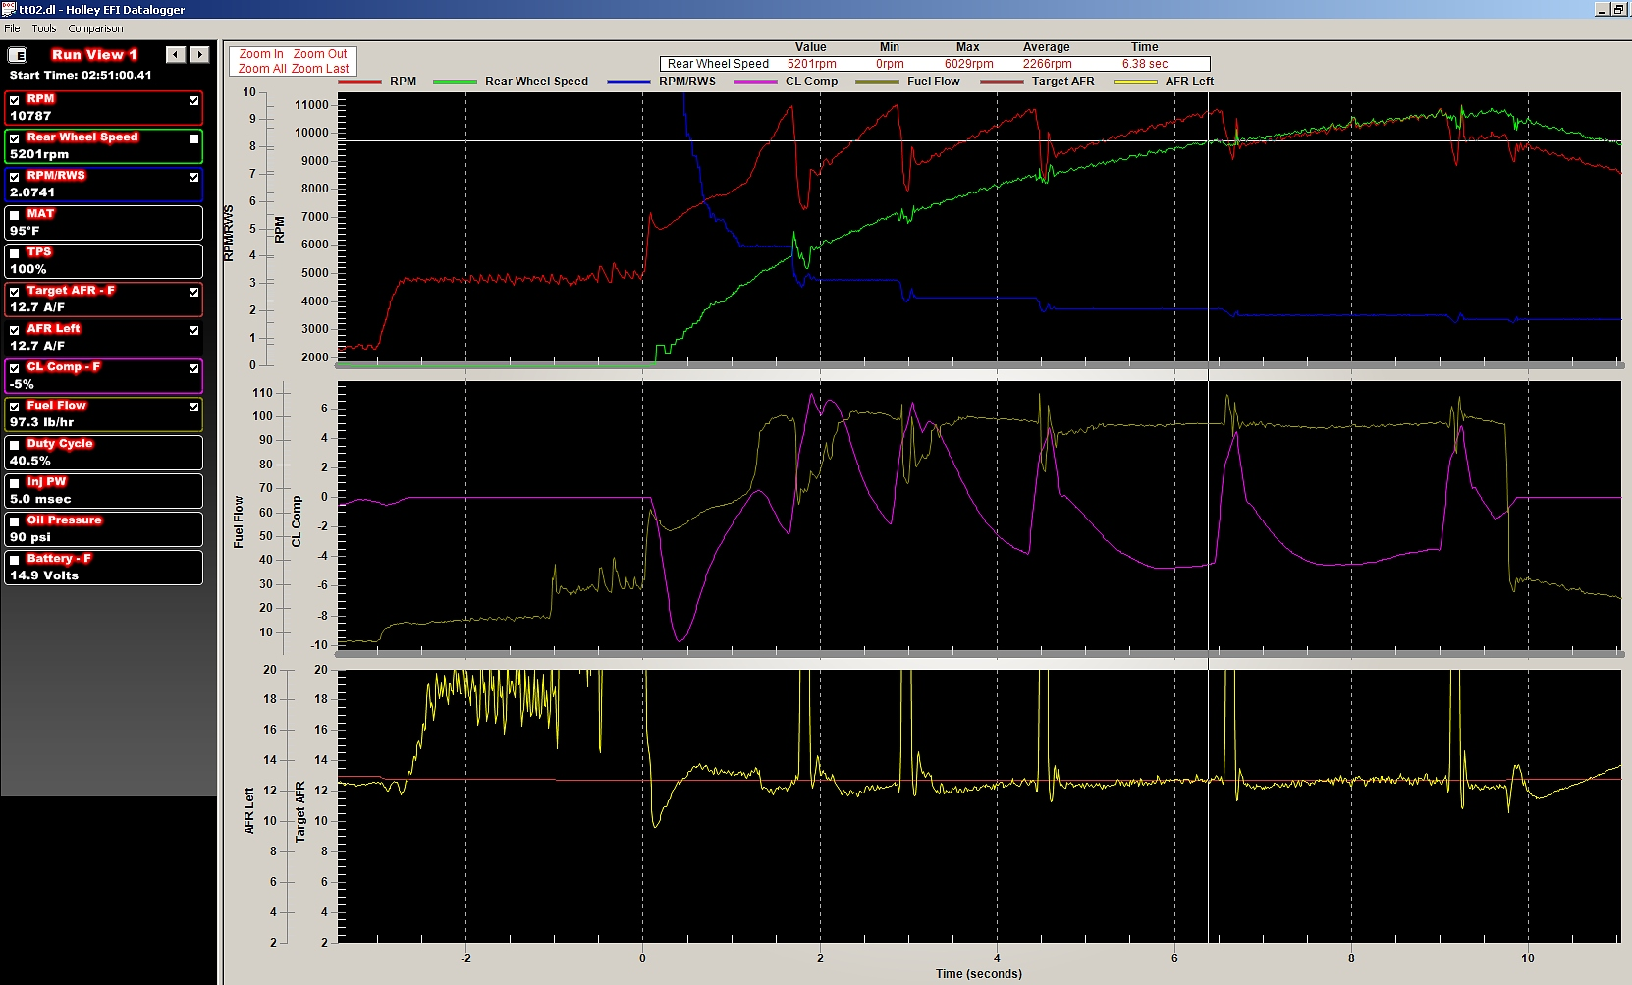
The Data Logger feature is top of the line. It samples all sensors at 100 samples per second. Standard data log items are TPS, MAP, CTS, MAT, A/F, Target A/F, Closed Loop Compensation, Closed Loop Status, Barometer, Learn Status, Fuel Pressure, Oil Pressure, Fuel Flow, Injector Pulse Width, Injector Duty Cycle, Ignition Timing, Nitrous Ramps, and Boost Ramps.

