FOR IMMEDIATE RELEASE
Contact: Dan Rudd
Phone: 321.972.8282
FAX: 321.972.5123
E-Mail: sales@mpsracing.com
Web: www.mpsracing.com
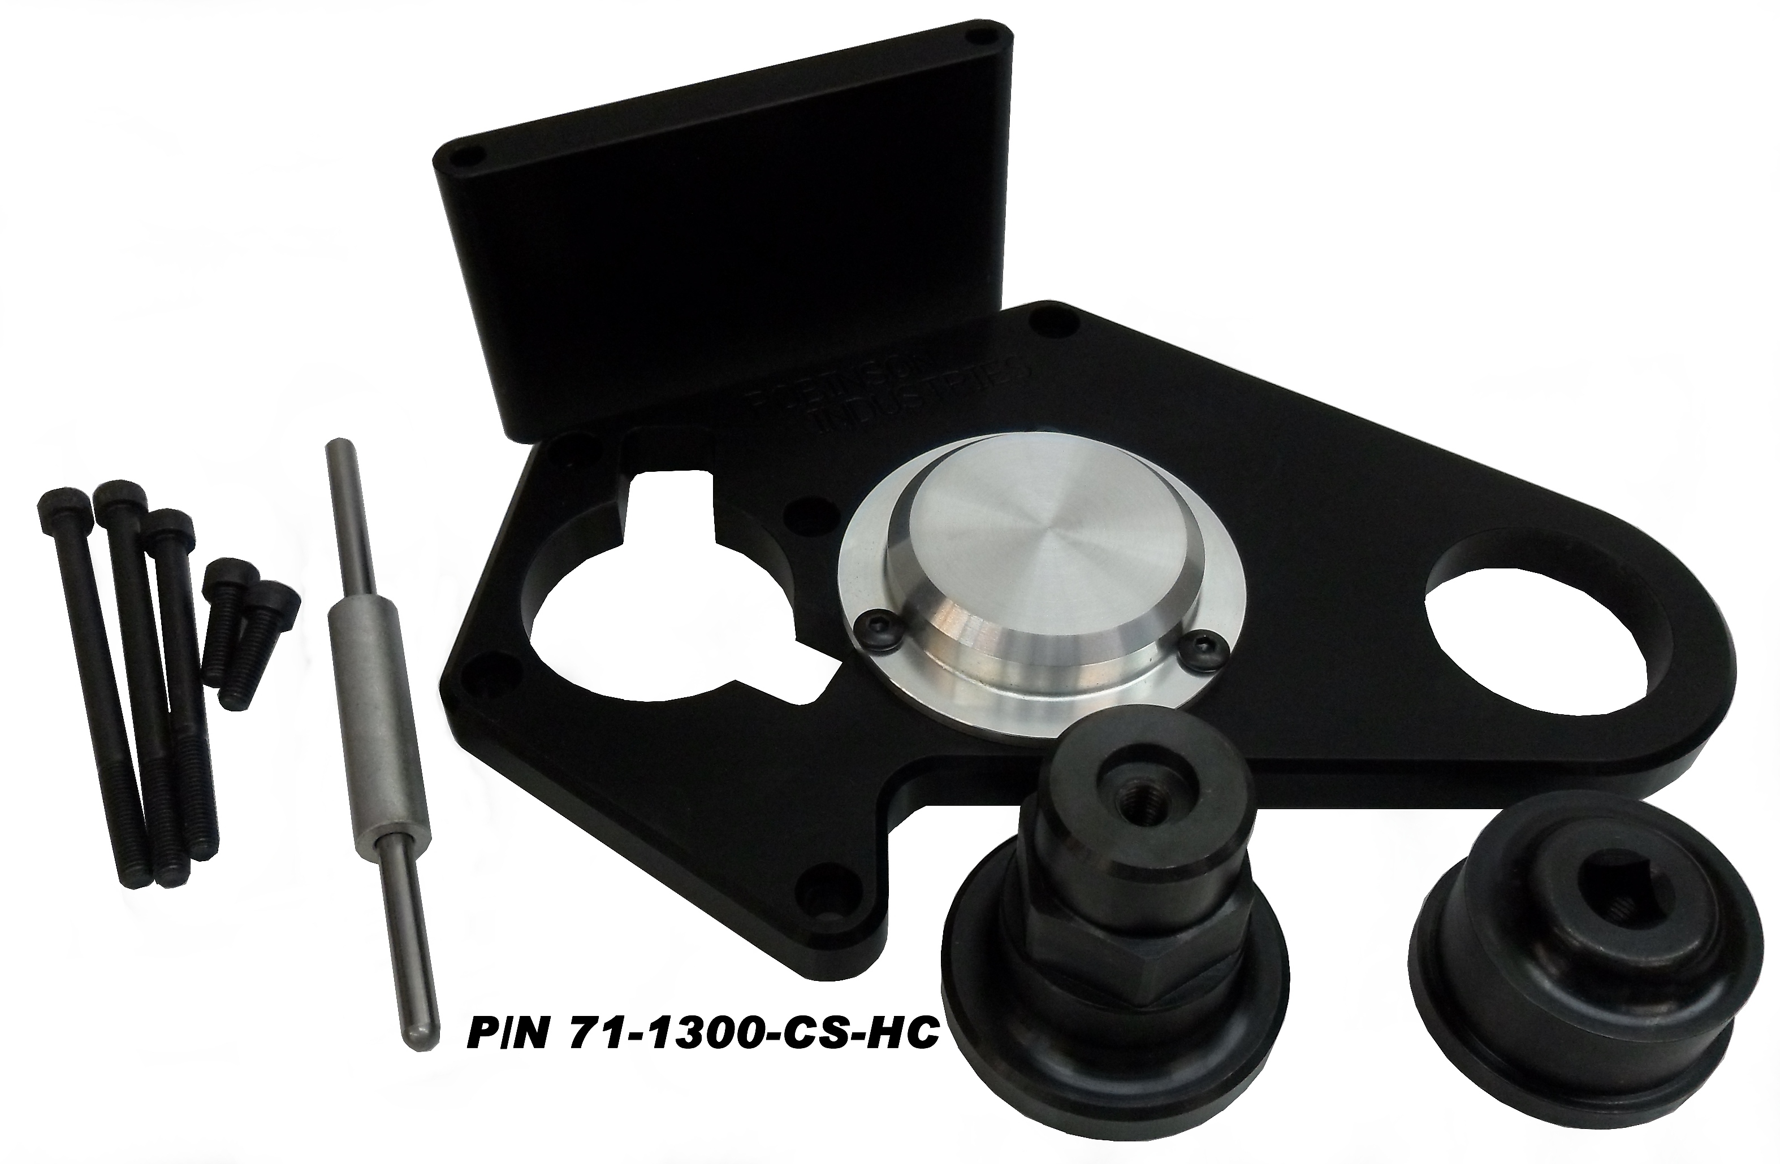

Robinson Output Shaft Support For Hayabusa

Casselberry, Florida, 07/26/2012 - Motorcycle Performance Specialties is excited to announce the immediate availability of the Robinson Output Shaft Support for Hayabusa. The output shaft support has a round steel anchor that is bolted to the swingarm pivot. The plate slides over the steel anchor and bolts to the cases with the bolts provided. An extended snout countershaft sprocket bolt then rides in the bearing fitted to the plate. This supports the end of the transmission output shaft preventing broken shafts and engine cases. A longer clutch pushrod is included. The output shaft support can be used with hand or slider clutches. If you have a “grudge bike” you need one of these!

P/N 71-1300-CS-HC are priced at $495.00 and are in stock for immediate shipment.
# # #

